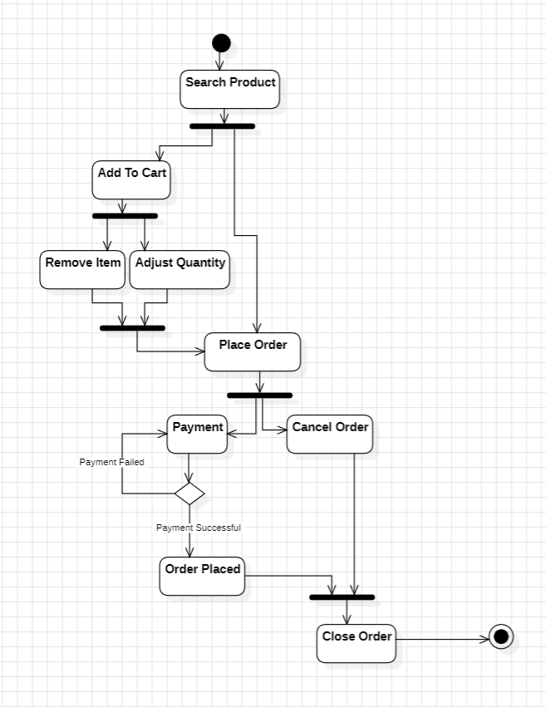

Fig: Activity Diagram of Placing Order in E-commerce application